Journal of Innovation Template

Authors:
Name  Organization/Company  email@address.com | Name  Organization/Company  email@address.com

Contents
1 Common Mistakes to Avoid 3
1.1 Updating Existing Articles 3
1.2 Title Page 3
1.3 Figures & Tables 3
1.4 Footnotes & References 4
1.5 Important Formatting Tips 4
2 Bullets 5
3 Sub-Bullets 6
4 Examples 6
5 Sub-Chapters 6
5.1 Chapter 4, Sub-Chapter 1 6
5.2 Chapter 4, Sub-Chapter 2 6
6 Figures 7
7 Tables 7
8 Footnotes 9
9 Sub-sections and Sub-sub-sections 9
9.1 Chapter 8, Sub-Chapter 1 9
9.1.1 Chapter 8, Sub-Chapter 1, Sub-Section 1 9
9.1.2 Chapter 8, Sub-Chapter 1, Sub-Section 2 9
9.1.3 Chapter 8, Sub-Chapter 1, Sub-Section 3 9
9.2 Chapter 8, Section 2 10
10 References 10
Annex A 10
A.1 Annex Section Title 10
A.1.1 Annex Sub-Section Title 10
Annex B 11
B.1 Annex Section Title 11
Acknowledgements 11

Figures
Figure 1-1: Paragraph set-up for line spacing to be used throughout the document. 5
Figure 6-1: Figure captions should end in periods. Caption text is 11-point Calibri (Body). Note the colon after the caption. Figures should be centered on the page and use the entire width of the page whenever possible. 7

Tables
Table 7-1: Sample Table with left alignment. Note the standard blue header with white interior borders, and the alternating gray and white boxes with blue interior borders. Use the entire width of the page whenever possible. 8
Table 7-2: Sample Table with two headings and center alignment. 9
Table 7-3: Sample Table with centered heads, left aligned text, and sub-bullets. 9

Please start the document with a one or more paragraphs of text, not a Chapter header. This section might be your abstract, introduction, or thesis statement.
- Text is 12-point Calibri (body).
- Line spacing throughout the document is 8 pt / 0 pt / Multiple / 1.08 as shown in Figure 1-1.

Common Mistakes to Avoid

Updating Existing Articles
When you are updating an existing paper, please use the published version as the starting point.

Title Page
- Please keep the title less than 7 words.
- Please write titles in formal academic style.
- Please don't change design, logo placement, or font/font size on the title page.
- Note: the title page has no page numbers or chapter heading.

Figures & Tables
- Please include tables for Figure & Table in the Table of Contents.
- Please include a cross-reference in the text for each Figure and Table.
- The format for all Figure & Table captions is Chapter Number - Figure Number, followed by a colon. (Figure 3-1: ... )
- Figure & Table captions should be written in sentence style and case, with a period at the end (not Chapter or Subhead case).
- Captions are Calibri 11 (Body), no italics.
- A format for Tables is included in the template. Note that the table headers have a standard background color.
- Unless they are very small, Figures & Tables should span the width of the page.
- Figures & Tables created from an outside source must be attributed.

Footnotes & References
Footnotes & References are two different things: A Reference is a citation to a source of information in a written work that appears at the end of the document. A Footnote is an explanatory or bibliographic note at the bottom of the page it appears.
References are typically listed at the end of a paper in a bibliography, while footnotes provide additional information or commentary within the text itself.
It's ok to include the same article reference in both Footnotes and the Reference list. But if you do, please make sure there is also a cross-reference in the text to the Reference section. If there are no cross-references in the text, please use “Bibliography” for the section name, rather than “References.”
- References go under a "Reference" chapter heading at the end of the document.
- Footnotes are Calibri 11 (Body), no italics.
- Footnotes are contiguous through the document.
- There is not an extra line space between the Figure and its caption.
- References must be in APA format, as shown in Section 12 below.
- Please add hyperlinks to all external references. (This will change the font to italics.)

Important Formatting Tips
- In the first page after the Table of Contents, the copy starts at the top of the page, there are no line spaces.
- Every page in the document has the same line spacing and paragraph spacing, as shown in Figure 1-1.
- There is one exception: for long lists of bullets, please check "Don't add space between paragraphs of the same style."
- Please remember to spell check and grammar check. (Pay special attention to names of people in the References).
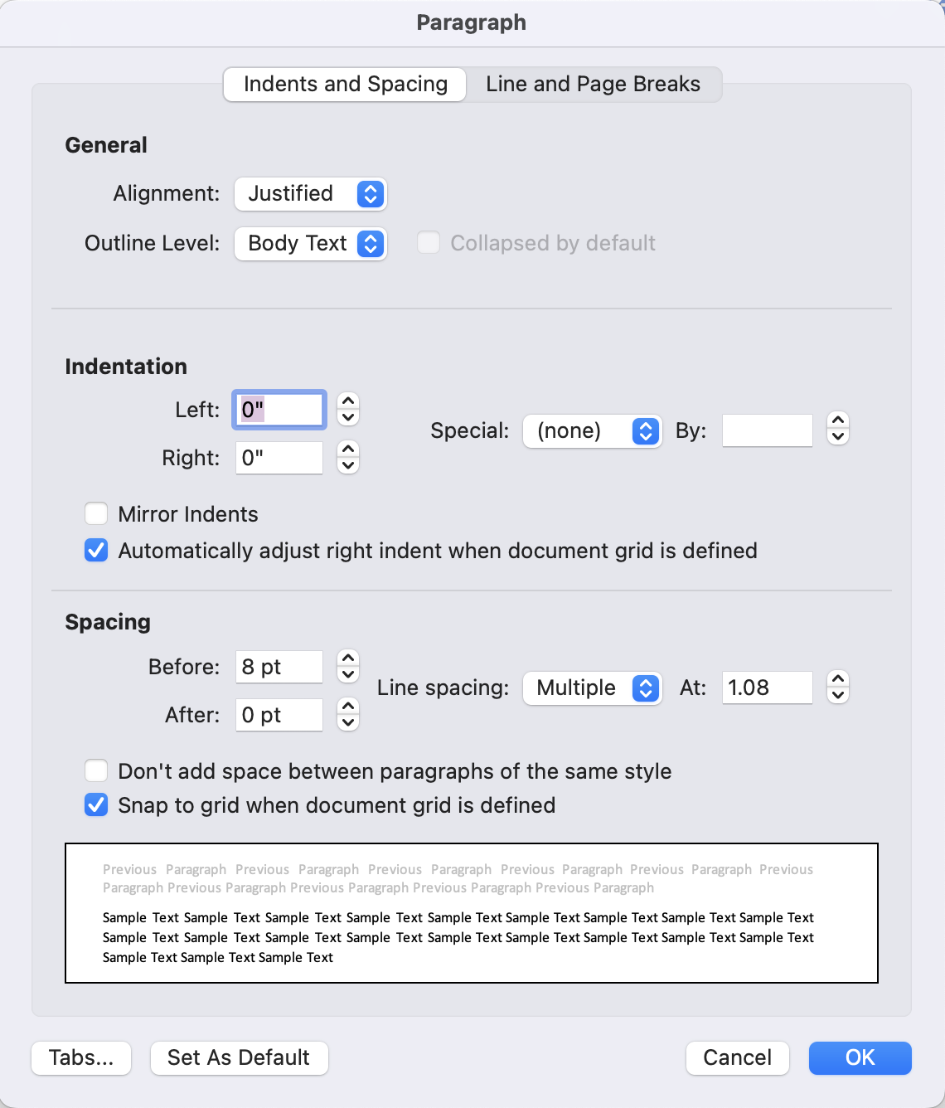
Figure 1-1: Paragraph set-up for line spacing to be used throughout the document.

Bullets
This is placeholder text. Lorem ipsum dolor sit amet, consectetur adipiscing elit, sed do eiusmod tempor incididunt ut labore et dolore magna aliqua. Ut enim ad minim veniam, quis nostrud exercitation ullamco laboris nisi ut aliquip ex ea commodo consequat. Duis aute irure dolor in reprehenderit in voluptate velit esse cillum dolore eu fugiat nulla pariatur. Excepteur sint occaecat cupidatat non proident, sunt in culpa qui officia deserunt mollit anim id est laborum.
- Bullet 1
- Bullet 2
- If several short bullets are used, in the Paragraph box, please select “Don’t add space between paragraphs of the same style.”

Sub-Bullets
This is placeholder text. Lorem ipsum dolor sit amet, consectetur adipiscing elit, sed do eiusmod tempor incididunt ut labore et dolore magna aliqua. Ut enim ad minim veniam, quis nostrud exercitation ullamco laboris nisi ut aliquip ex ea commodo consequat.
- Bullet 1
  - Sub-Bullet 1
  - Sub-Bullet 2

Examples
Here is an example of an Example. It is often used to describe use cases or in place of bullets with a lot of text. It is a simple table:
Example | Lorem ipsum dolor sit amet, consectetur adipiscing elit, sed do eiusmod tempor incididunt ut labore et dolore magna aliqua. Ut enim ad minim veniam, quis nostrud exercitation ullamco laboris nisi ut aliquip ex ea commodo consequat.  Duis aute irure dolor in reprehenderit in voluptate velit esse cillum dolore eu fugiat nulla pariatur. Excepteur sint occaecat cupidatat non proident, sunt in culpa qui officia deserunt mollit anim id est laborum.

Sub-Chapters
This is placeholder text. Lorem ipsum dolor sit amet, consectetur adipiscing elit, sed do eiusmod tempor incididunt ut labore et dolore magna aliqua. Ut enim ad minim veniam, quis nostrud exercitation ullamco laboris nisi ut aliquip ex ea commodo consequat.

Chapter 4, Sub-Chapter 1
This is placeholder text. Lorem ipsum dolor sit amet, consectetur adipiscing elit, sed do eiusmod tempor incididunt ut labore et dolore magna aliqua. Ut enim ad minim veniam, quis nostrud exercitation ullamco laboris nisi ut aliquip ex ea commodo consequat.

Chapter 4, Sub-Chapter 2
This is placeholder text. Lorem ipsum dolor sit amet, consectetur adipiscing elit, sed do eiusmod tempor incididunt ut labore et dolore magna aliqua. Ut enim ad minim veniam, quis nostrud exercitation ullamco laboris nisi ut aliquip ex ea commodo consequat.

Figures
Figure cross-references should include the chapter number, and the link shows the caption label and number. Every figure and table should have a cross-reference in the text. Here is the cross-reference to Figure 5-1:
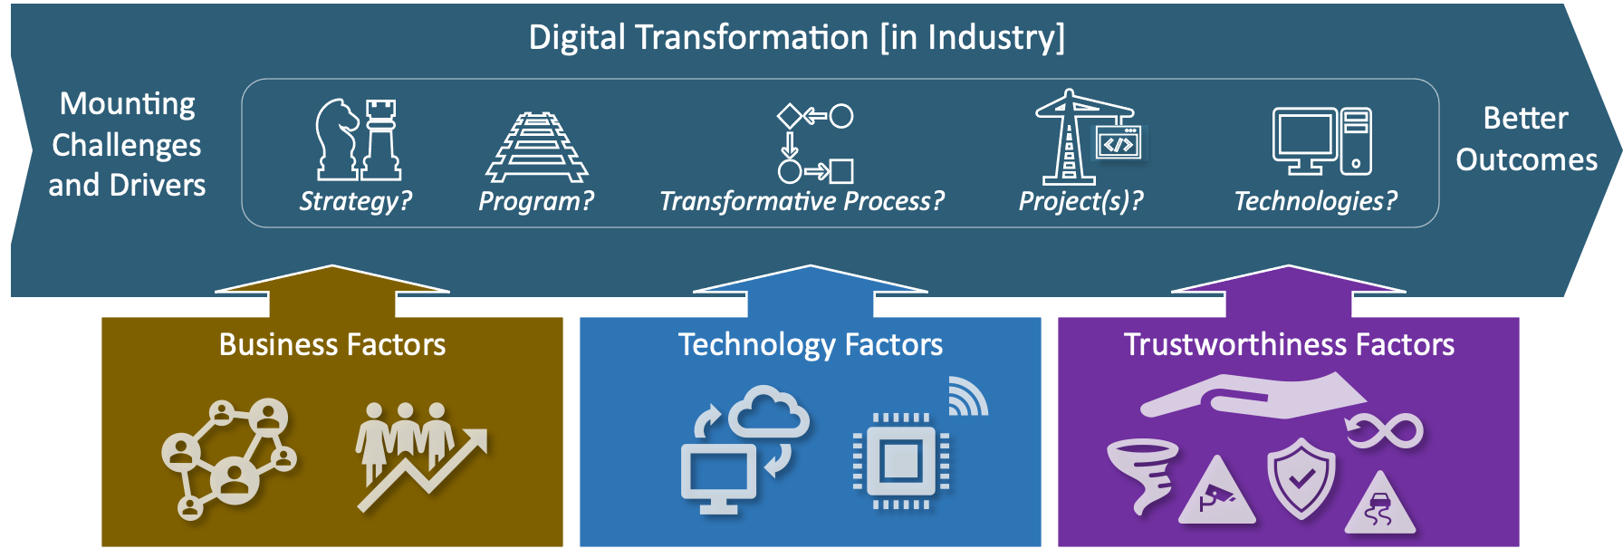
Figure 6-1: Figure captions should end in periods. Caption text is 11-point Calibri (Body). Note the colon after the caption. Figures should be centered on the page and use the entire width of the page whenever possible.

Tables
Table cross-references should include the chapter number, and the link shows the caption label and number. Tables should be centered on the page. Here are the cross-references to Table 7-1, Table 7-2, and Table 7-3.
Font Calibri 12 point bold | Table Col 2 | Table Col 3
Font between Calibri 10 and 12 point regular. | Cell 1b | ✓
Cell 2a | Cell 2b
Cell 3a | Cell 3b | ✓
Table 7-1: Sample Table with left alignment. Note the standard blue header with white interior borders, and the alternating gray and white boxes with blue interior borders. Use the entire width of the page whenever possible.
Table Description
Col Title a | Col Title b | Col Title c
Cell 1a | Cell 1b | ✓
Cell 2a | Cell 2b
Cell 3a | Cell 3b | ✓
Cell 4a | Cell 4b
Table 7-2: Sample Table with two headings and center alignment.
Table Col 1 | Table Col 2 | Table Col 3
Cell 1a (spacing) | Cell 1b (spacing) | Cell 1c (spacing)
Cell 2a (no spacing) | Cell 2b (no spacing) | Cell 2c (no spacing)
Cell 3a (no spacing) | Cell 3b (no spacing) | Cell 3c (no spacing)
- Cell 4a (list) | - Cell 4b (list) | - Cell 4c (list)
- Cell 5a (list) | - Cell 5b (list) | - Cell 5c (list)
Cell 6a (spacing) | Cell 6b (spacing) | Cell 6c (spacing)
Col 7a (no spacing) | Col 7b (no spacing) | Cell 7c (no spacing)
Table 7-3: Sample Table with centered heads, left aligned text, and sub-bullets.

Footnotes
Footnotes are formatted as bottom of the page with continuous numbering throughout the document.
This is placeholder text. Lorem ipsum dolor sit amet, consectetur adipiscing elit, sed do eiusmod tempor incididunt ut labore et dolore magna aliqua. Ut enim ad minim veniam, quis nostrud exercitation ullamco laboris nisi ut aliquip ex ea commodo consequat. Duis aute irure dolor in reprehenderit in voluptate velit esse cillum dolore eu fugiat nulla pariatur. Excepteur sint occaecat cupidatat non proident, sunt in culpa qui officia deserunt mollit anim id est laborum.

Sub-sections and Sub-sub-sections
This is placeholder text. Lorem ipsum dolor sit amet, consectetur adipiscing elit, sed do eiusmod tempor incididunt ut labore et dolore magna aliqua. Ut enim ad minim veniam, quis nostrud exercitation ullamco laboris nisi ut aliquip ex ea commodo consequat. Duis aute irure dolor in reprehenderit in voluptate velit esse cillum dolore eu fugiat nulla pariatur.

Chapter 8, Sub-Chapter 1
This is placeholder text. Lorem ipsum dolor sit amet, consectetur adipiscing elit, sed do eiusmod tempor incididunt ut labore et dolore magna aliqua. Ut enim ad minim veniam, quis nostrud exercitation ullamco laboris nisi ut aliquip ex ea commodo consequat.

Chapter 8, Sub-Chapter 1, Sub-Section 1
This is placeholder text. Lorem ipsum dolor sit amet, consectetur adipiscing elit, sed do eiusmod tempor incididunt ut labore et dolore magna aliqua. Ut enim ad minim veniam, quis nostrud exercitation ullamco laboris nisi ut aliquip ex ea commodo consequat.

Chapter 8, Sub-Chapter 1, Sub-Section 2
This is placeholder text. Lorem ipsum dolor sit amet, consectetur adipiscing elit, sed do eiusmod tempor incididunt ut labore et dolore magna aliqua. Ut enim ad minim veniam, quis nostrud exercitation ullamco laboris nisi ut aliquip ex ea commodo consequat.

Chapter 8, Sub-Chapter 1, Sub-Section 3
This is placeholder text. Lorem ipsum dolor sit amet, consectetur adipiscing elit, sed do eiusmod tempor incididunt ut labore et dolore magna aliqua. Ut enim ad minim veniam, quis nostrud exercitation ullamco laboris nisi ut aliquip ex ea commodo consequat.

Chapter 8, Section 2
This is placeholder text. Lorem ipsum dolor sit amet, consectetur adipiscing elit, sed do eiusmod tempor incididunt ut labore et dolore magna aliqua. Ut enim ad minim veniam, quis nostrud exercitation ullamco laboris nisi ut aliquip ex ea commodo consequat.

References
[1] Author, I.N. (Year). Title of the Article. Title of the Journal of Periodical, volume number (issue number), page numbers. doi:0000000/000000000000
[2] Author, I.N. (Year). Title of the Article. Title of the Journal of Periodical, volume number (issue number), page numbers. https://doi.org/10.7748/phc.2016.e1162.
[3] Liongosari, E.S. (2024). Industrial Use of Generative AI: Opportunities and Risk, OMG Journal of Innovation (24th Edition), pp 46-57. https://www.objectmanagementgroup.org/wp-content/uploads/sites/8/2024/03/JOI_20240318_Industrial_Use_of_Generative_AI_Opportunities_and_Risks_standalone.pdf
References must follow APA formatting guidelines, as shown here. References within the text of the document do not require internal links to the References section.
If possible, please include the DOI (digital object identifier) number at the end of your reference, as shown in [1]. If a DOI number is not available and you accessed the article online, please give the URL with hyperlink of the journal's home page, as shown in [2]. If there is no DOI number, please give the URL with hyperlink, as shown in [3].

Annexes are synonymous with Appendices.
- Annex Section Title
This is placeholder text. Lorem ipsum dolor sit amet, consectetur adipiscing elit, sed do eiusmod tempor incididunt ut labore et dolore magna aliqua. Ut enim ad minim veniam, quis nostrud exercitation ullamco laboris nisi ut aliquip ex ea commodo consequat.
- Annex Sub-Section Title
This is placeholder text. Lorem ipsum dolor sit amet, consectetur adipiscing elit, sed do eiusmod tempor incididunt ut labore et dolore magna aliqua. Ut enim ad minim veniam, quis nostrud exercitation ullamco laboris nisi ut aliquip ex ea commodo consequat.

- Annex Section Title
This is placeholder text. Lorem ipsum dolor sit amet, consectetur adipiscing elit, sed do eiusmod tempor incididunt ut labore et dolore magna aliqua. Ut enim ad minim veniam, quis nostrud exercitation ullamco laboris nisi ut aliquip ex ea commodo consequat.

Acknowledgements
The views expressed in the OMG Journal of Innovation are the author’s views and do not necessarily represent the views of their respective employers nor those of the Object Management Group® (OMG®).
© 2024 The OMG logo is a registered trademark of Object Management Group®. Other logos, products and company names referenced in this publication are property of their respective companies.
- Return to OMG Journal of Innovation landing page for more articles and past editions.

Footnote text is 11-point Calibri (Body), regular. Please add one space after the footnote number. Line spacing between multiple footnotes is 3 pt / 0 pt / Multiple / 1.08.

